Rotating Leslie
Written by Martyn
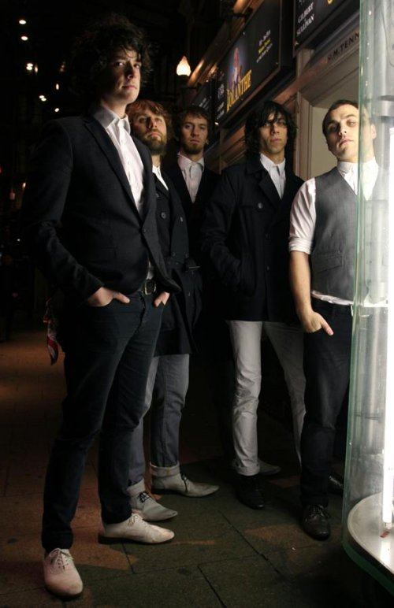
Greg Phizacklea (Voice Box)
Adrian Timbers (Science and Voice Box)
Stuart Timbers (Basslines)
Dan Cox (Blinky Guitars)
Steve Temple (Putash Grooves)
Rotating Leslie met at school in Hertfordshire when they were just 12 years old, they formed a friendship through their love of music, laughter and whatever cheap thrills they could get there hands on. They still have that friendship today and still have that love of music.
After years DJing on the London Free Party Scene the band came into it’s own in Coates Manor, the tumbledown farmhouse the band lived, practiced, wrote and recorded in for the last two years. This was also the venue for the legendary Woodendstock sessions, which saw the Leslie’s and their friends come together to party and wake up the sleepy countryside for the weekend.
It was at the Manor that the band released their first self-pressed 7”’s which sold out in weeks and received great acclaim from the press and radio. The video for one 7” was filmed in their front garden for nothing and ended up on MTV. It’s the band’s self contained DiY ethos which attracted the attention of the fans and record companies alike.
They have gained a large and loyal following from their incendiary London warehouse parties and extensive gigging over the last 12 months. This has seen them support The View at the launch party for E4’s Skins show, The Subways, The Rifles, Nice Black Alps, and their old flat mates Goldie Lookin Chain to name a few. They were even asked if The Subways could support them at a secret hometown gig and have since become firm friends.
NME described their sound as ’gritty, harmonic, pop’; call it what you will, they have steered away from the obvious indie clichés and instead, relied on their diverse influences from 80’s metal to electro house and created something fresh and exciting
The band have been fervently writing and recording for the last few months culminating with sessions at Eden and RAK studios (home to sessions from Radiohead, Arctic Monkeys, Primal Scream and The Sex Pistols) in winter 2007
With Mind On My Money, Hackney Courage, Fire!Fire! and Send In The Lions they have realised their sound and with the songs receiving global airplay and support from stalwarts both side of the pond (most notably on L.A’s Indie 103), 2008 is becoming a good vintage for The Leslie’s

ArtistsOnLineMusic Player/
- Fire Fire.mp3
- Mind On My Money.mp3
- Send In The Lions.mp3
- The Beatless.mp3>>Play now!
Powered by MPJax Plugin
Quoc-Huy

User Comments
Please login or register to add comments

